Mine Safety & Training Section

Contact Safety

OCT. 2016
By: Rod Neils

HAND/POWER TOOL SAFETY

Hand tools and power tools have played an important role throughout human history. They have become commonplace in our daily lives and are present in just about every occupational setting to include mining. In addition, many of these same tools can be found in most of our homes. While these tools serve very important functions or roles in completing a task or project, they can be hazardous and potentially cause severe injuries when used or maintained improperly. It is important for employees to understand the hazards associated with hand/power tools; employee responsibilities when using tools; management responsibilities when it comes to hand/power tool safety; examples of improper use and when to inspect and replace damaged tools; basic rules that can prevent hazards;.
While hand tools and power tools present hazards when being used, the type and nature of hazards can very.
When it comes to hand tools and their use, the greatest hazard comes from misuse and/or improper maintenance. Some examples can include:
- Using a chisel as a screw driver, causing the tip of chisel to break off, hitting an employee.

- Pushing versus pulling a wrench to loosen a fastener.
- When using a knife, cutting towards the body.
- Using a hammer or axe with a wooden handle that is loose or splintered, causing the head to fly off and strike an employee.
- Impact tools such as chisels, wedges, or punches with mushroomed heads. Mushroomed heads may splinter causing sharp objects to strike an employee.
To prevent hazards associated with power tools, to following precautions should be followed by employees:
- Never carry a power tool by the cord and never yank the cord to disconnect it from a power receptacle.
- Disconnect tools when they are not in use, before service and repair, or when changing blades, bits, and cutters.
- Follow manufacturer instructions for maintenance, adding accessories and inspecting power tools.
- Wear appropriate clothing for the job. Loose clothing and jewelry can become entangled in moving parts, resulting in injury.
- Red tag any power equipment that is damaged or unsafe to operate.
- Ensure employees not directly involved in the task are kept at a safe distance.

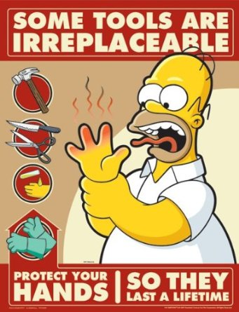

While the hazards and precautions discussed above can help to reduce or eliminated injuries associated with hand/power tool use, it is important for both management and employees to under their respective responsibilities when it comes to tool safety.
Employees should:
- Anticipate all work hazards.
- Ensure all safeguards to include safety mechanisms and PPE are utilized.
- Conduct routine inspections of tools to ensure they are well maintained and ready for use.
- Report to supervisor or manager any tool that needs to be replaced immediately.
- Follow all safety guidelines when using hand/power tools in accordance with company policies and manufacturer instructions.
Supervisors/Management should:
- Anticipate all work hazards.
- Enforce the use of safeguards and PPE.
- Replace all damaged tools identified by employees.
- Ensure employees are properly trained on the use of tools in accordance with manufacture instructions and company policies.
By working in a collaborative effort, both employees and management can ensure hazards are identified with each task and either controlled or eliminated. By follow some basic rules, hand/power tools can be used to accomplish the job in a safe and efficient manner. The primary rules to follow include:
- All tools should be kept in good condition with regular maintenance.
- Use the right tool for the job.
- Prior to using, examine each tool for damage and replace when necessary.
- Follow manufactures’ instructions when using any tool.
- Ensure proper personal protective equipment (PPE) is provided and used by the employee when using hand/power tools.

Seems simple, right? Unfortunately, the Mine Safety and Training Section routinely issues citations to correct deficiencies with the use of hand/power tools. Below are few examples of what inspectors routinely find along with the cited regulation.
- Scaling bars damaged to point where an employee is exposed to a potential hazard. 56/57.3202
- Ladders with damaged rungs. 56/57.14205
- Using a gas powered pressure washer without the use proper eye protection. 56/57.15004
- Proper shielding when welding. 56/57.14213
- Punch/wedge found with the ends mushroomed. 56/57.14100(b)
- Hammers and Sledge Hammers with broken handles. 56/57.14100(b)

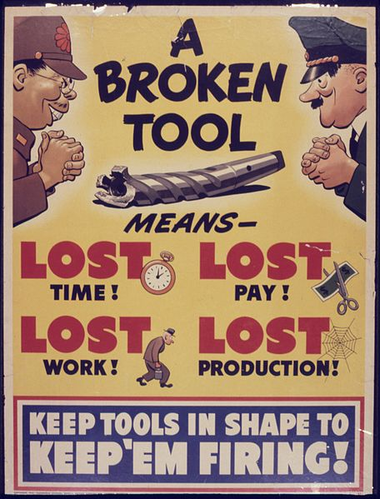
Using hand/power tools safely can be achieved throughout the mining community. It takes a collaborative effort on the part of employees and management to establish and follow basic rules, guidelines and procedures.

When using tools always ask yourself: Do I have the right tool for the job?

Have I been trained on how to use the tool correctly?

Is the tool in good condition? Do I have the right PPE?

Is there a place to store this tool when not in use?

If you are able to answer yes to these questions, then you are able to work safely.

References:

Hand and Power Tools
https://www.osha.gov/Publications/osha3080.html

Hand Tool Safety
https://www.bwc.ohio.gov/downloads/blankpdf/SafetyTalk-Handtools.pdf

QUIZ

1) When it comes to hand tools and their use, the greatest hazard comes from
_____________________ and/or

2) _____________ tools when not in use, before service and repair, or when changing blades, bits and cutters.

3) ________ _____ ____________, examine each tool for damage and replace when necessary.

4) ________________ should ensure employees are properly trained on the use of tools in accordance with manufacture instructions and company policies.

If there is any specific topics you would like to learn more about please write on line below.

Employee:_____________________Date:___________

Mine/Company:________________________________

Address:_____________________________________

City:________________State:_______Zip:__________

