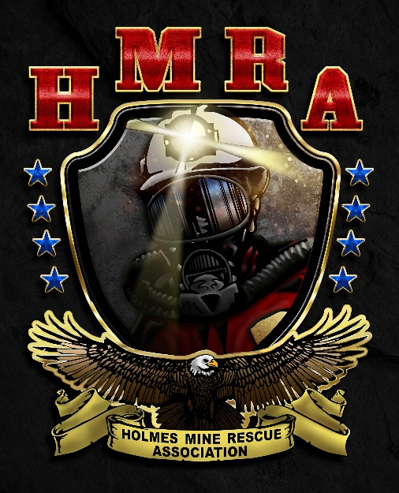

April 3, 2024

APPLICANTS: 2024 National Mine Rescue,

First Aid, Bench, Pre-shift, and Technician

Team Competition

The 2024 National Mine Rescue, First Aid, Bench, Pre-shift, and Technician Team Competition which will be held in Lexington, Kentucky on August 12 – 15, 2024 at the Central Bank Center (430 West Vine Street, Lexington, KY 40507). Please **print clearly or type** the information on the registration form, see attached, as it will be used in preparing many aspects of the contest program.

To offset the costs of expenses, a charge of $3,500 will be required. This charge will cover the following:

* 1 mine rescue team, 1 first aid team, up to 2 benchmen, 1 technician team and 2 pre-shift contestants
* 10 awards banquet tickets
* Lunch will be provided during Mine Rescue lock-up.

If your company would like to have additional participants, a charge of $500 per benchman, technician team, pre-shift contestant, or first aid team will be collected to cover the additional expenses, as well as a banquet ticket.

This charge **does not include lodging rooms.** Therefore, it will be the responsibility of each team trainer/manager to arrange for accommodations. Listed below are the hotels that have blocked off rooms for the 2024 event at a special competition rate, and both are attached to the Convention Center. The online reservation sites and phone numbers are listed with each lodging facility, and **we strongly encourage you to make reservations as quickly as possible,** as rooms will fill up fast. Please reference the “Group Code” in the chart below to receive the special lodging rate at the hotel. Once the specified number of rooms has been depleted, standard hotel rates will apply.

2024 National Mine Rescue, First Aid, Bench, Pre-shift, and Technician Team Competition

|  |  |  |  |  |
| --- | --- | --- | --- | --- |
| **Hotel** | **Location** | **Price** | **Contact Information** | **Group Code** |
| HYATT | 401 W. High Street | **$141** | **Online reservations for HYATT:**  [https://www.hyatt.com/en-US/group-booking/LEXRL/G-MR24](https://urldefense.proofpoint.com/v2/url?u=https-3A__www.hyatt.com_en-2DUS_group-2Dbooking_LEXRL_G-2DMR24&d=DwMFAg&c=oDwORbqiAyI2S1E4GXNhG8NHIJckvCGWArFTLM6Zp04&r=KImNoSb03UBI7TlxzDujyFue8W4yu2dyKQ_JlaupQS4&m=5G-cVhTM4s5ECrpQF1lhdH-2BvoiyrBduJAs3NdBDilGhsPT53Hl-27F2KNonMVo&s=lhRxSbzXDnu1W_a0YdFbSz8ybuGTDtRkVhTAU49XHeQ&e=)  **Call in code:**  800.233.1234 and ask for Code G-MR24 | Code: G-MR24 |
| HILTON Lexington Downtown | 369 W. Vine Street | **$149** | <https://www.hilton.com/en/attend-my-event/nationalminerescuecontest2024/>  **Code: NMRC24** | Code: NMRC24 |

**Schedule of Events**

* First Aid and Bench Competition, August 12, 2024
* Mine Rescue – Coal and Metal Competition, August 13-14, 2024
* Pre-shift and Technician Team Competition, August 15, 2024
* Awards Banquet: August 15, 2024, at 6:00 PM at the Central Bank Center. Any additional banquet tickets you wish to purchase outside of the 10 you will receive will cost $50.00 each.

Payments must be in the form of a check made payable to **Holmes Mine Rescue Association – Unified** and mailed to the following address:

Holmes Mine Rescue Association - Coal

ATTN: David Grimm

3498 Highway 805

Jenkins, KY 41537

[dag@csecorporation.com](mailto:dag@csecorporation.com)

**The monies paid are non-refundable.**

All registration forms and associated fees are due by June 17, 2024.

If you have any questions concerning registration, payment or extra banquet tickets please contact David Grimm at [dag@csecorporation.com](mailto:dag@csecorporation.com) or by phone at (412)418-0612.