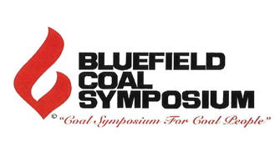

Individual Reservation Form
NAME
JOB TITLE
PREFERRED NAME ON BADGE
COMPANY
ADDRESS
EMAIL
WEB ADDRESS
PLEASE CIRCLE PACKAGE REQUIRED:
Monday Dinner Steak or Fish. Tuesday Dinner Steak or Fish.
Package A – Everything - $495.00 per person
Three Technical Sessions, Two Dinners and Live Entertainment, and One Lunch Package B – Symposium Less Meals - $325.00 per person
Three Technical Sessions, Evening Speaker and Live Entertainment
Package C – Monday or Tuesday Dinner Only - $75.00 per person
Package D – Monday Evening Less Dinner - $40.00 per person
Coal Operator, Jimmy Brock, Chairman & CEO, CONSOL Energy. Keynote Address, plus
Twitty and Lynn, a Salute to Conway & Loretta, live entertainment
Package E – Tuesday Evening Less Dinner - $40.00 per person
Mike Quillen, Founder & Retired CEO, Alpha Metallurgical Resources, Keynote Address plus entertainment by Exile performing songs from their numerous hit records.
Package A – (Student or Retired) Everything - $225.00 per person
Package D or E (Student or Retired) Monday Evening or Tuesday Evening Less Dinners – no charge
Package F – Everything plus Table Top and MINExpo® Enhancement Package - $995.00 per person
TERMS & CONDITIONS
1. Payment in full must be received by August 9, 2024
2. Payment enclosed: Check
3. All payments on this form should be payable to Chamber of Commerce of the Two Virginias
4. Please charge my: Mastercard Visa American Express
Card number Expiration date CVV code Zip Code
5. To phone in reservation or for wire transfer information, phone the Chamber at (304) 327-7184
6. In the case of Package F, payment in full must be received to reserve your place and position
7. This reservation may be scanned and emailed to debbie@coctwovirginias.com or mailed to Chamber
of Commerce of the Two Virginias, 619 Bland Street, Bluefield, WV 24701
ONLINE REGISTRATION COMING IN JUNE Form BCS 5A (revised June 18)

